CS 380

Exercise 5

My repository for this class is under CS 380 – Computer Networks

<https://github.com/jarodNakamoto/College-CS-Courses.git>

3.1 Verifying the Network

IP config

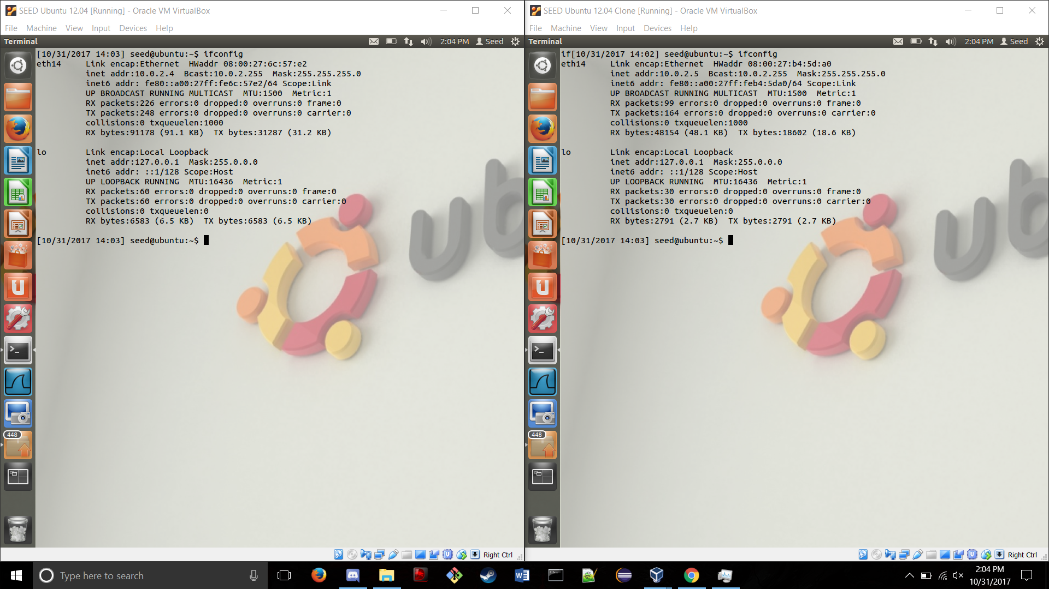

Ping

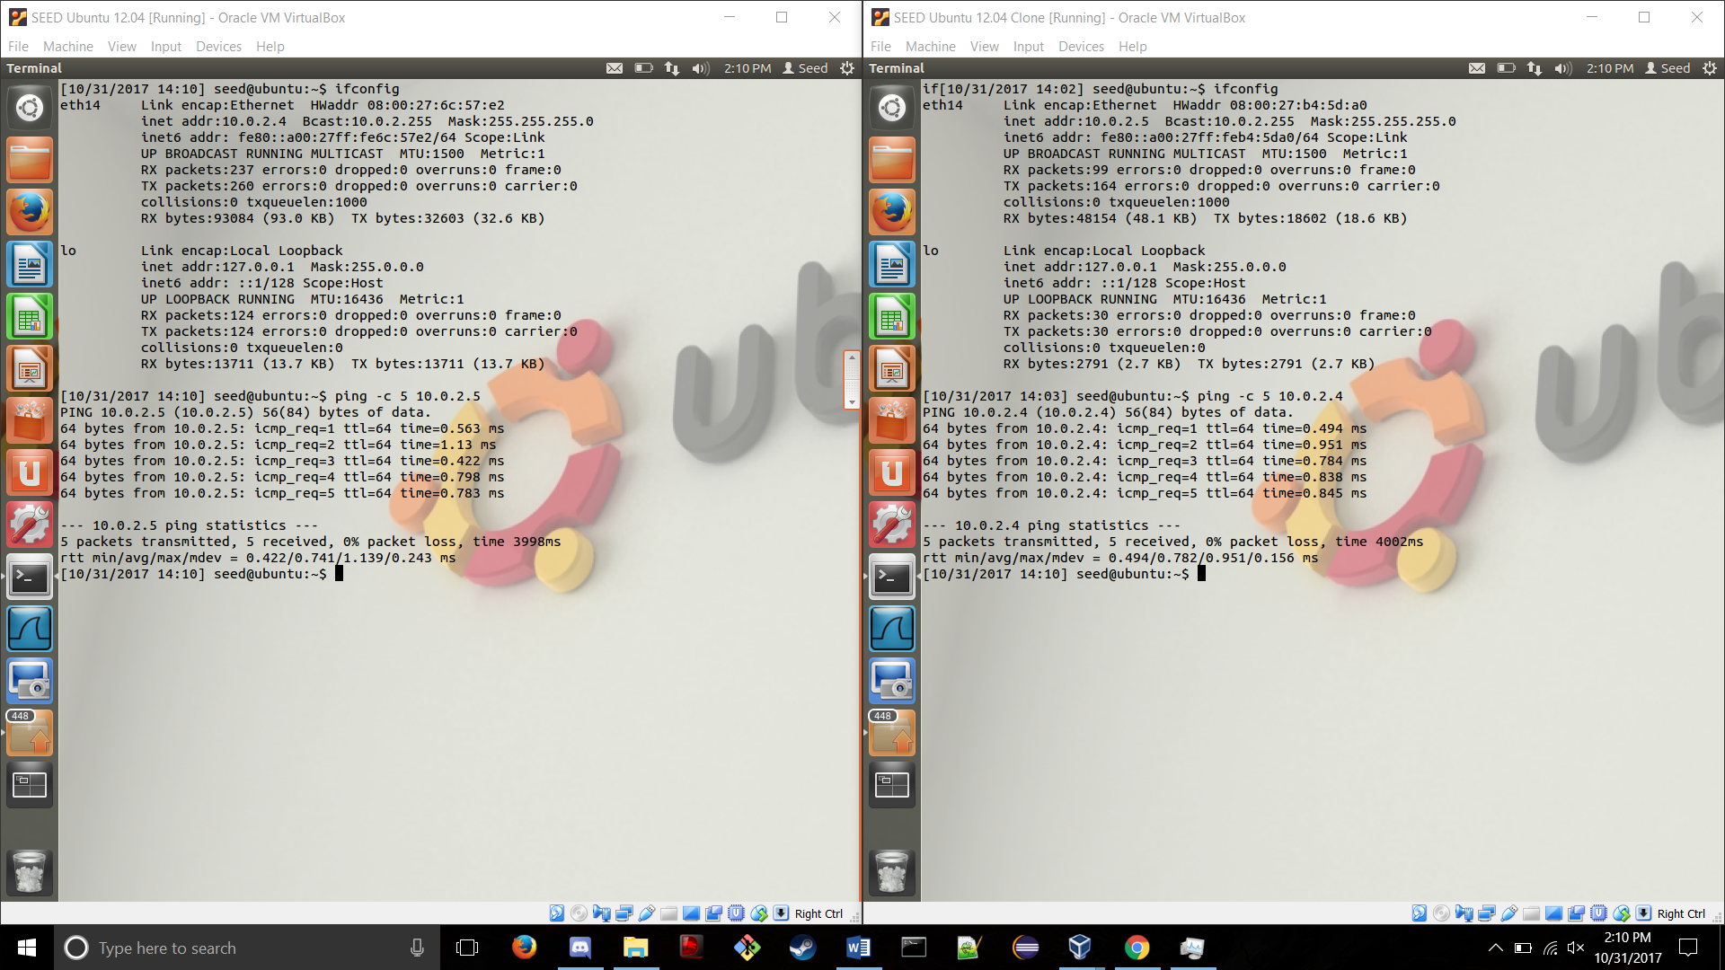

3.2 Packet Sniffer

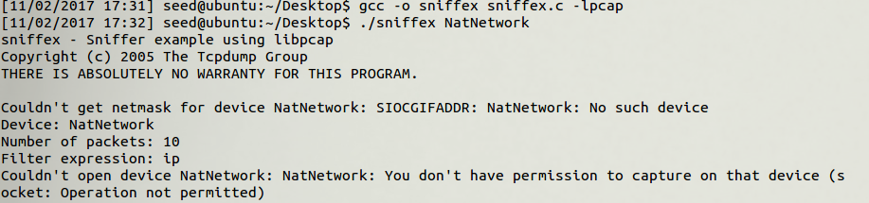

When pinging it with normal privileges, it says that we have insufficient privileges to run this program which means that the OS blocks it for security reasons.

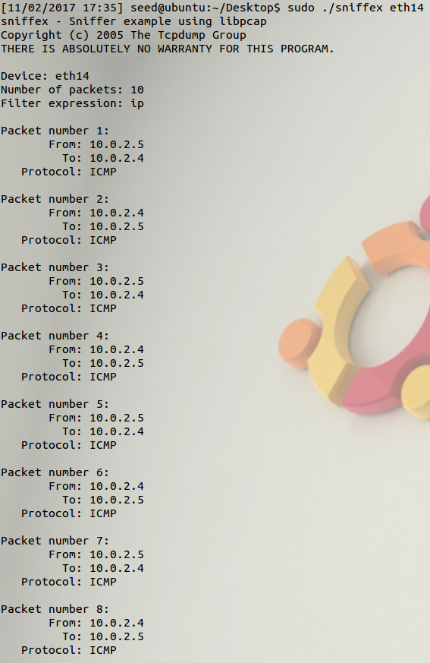  
It works after running it in admin, so it was just a security block by the kernel.

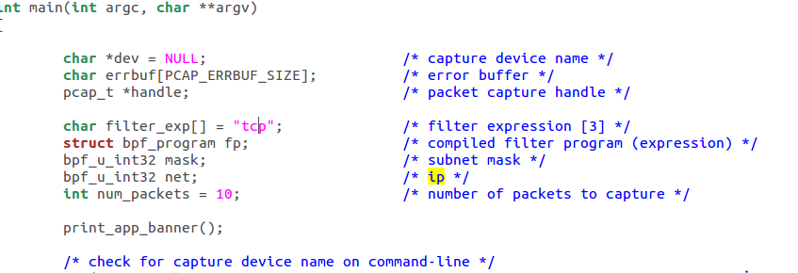

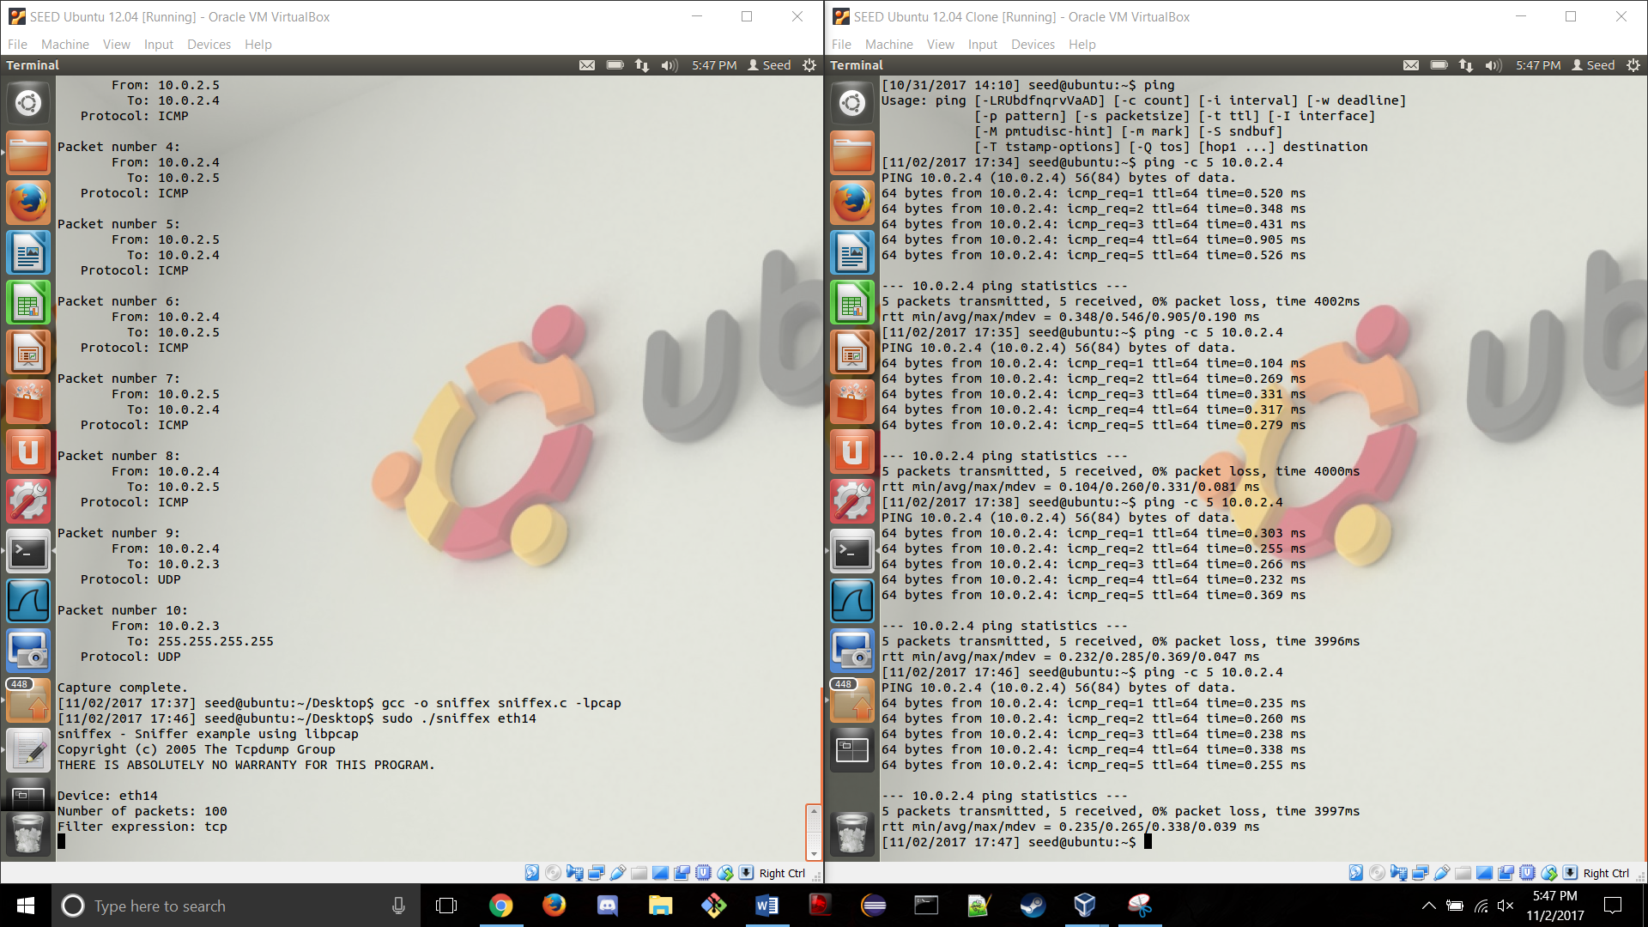

After pinging it twice, there was no change which means there are no tcp packets sent by ping.

3.3 Problem 3: Password Sniffing

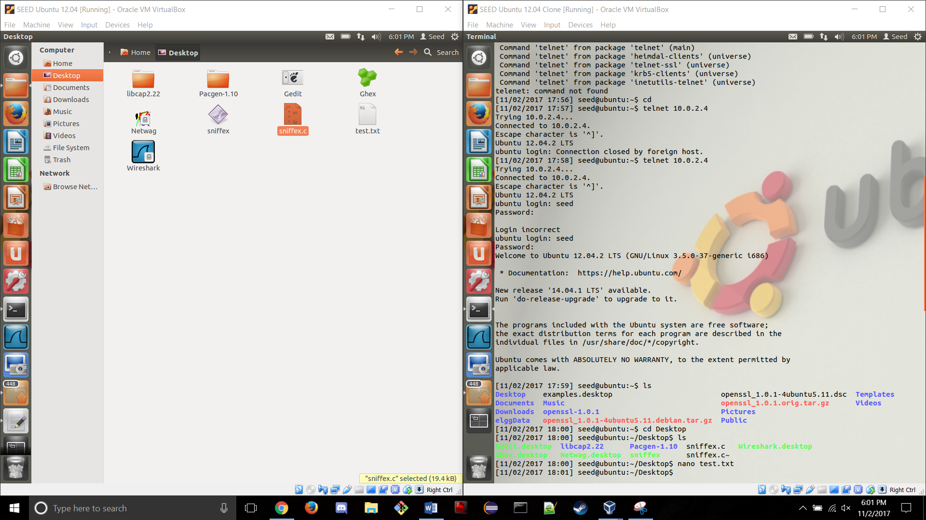

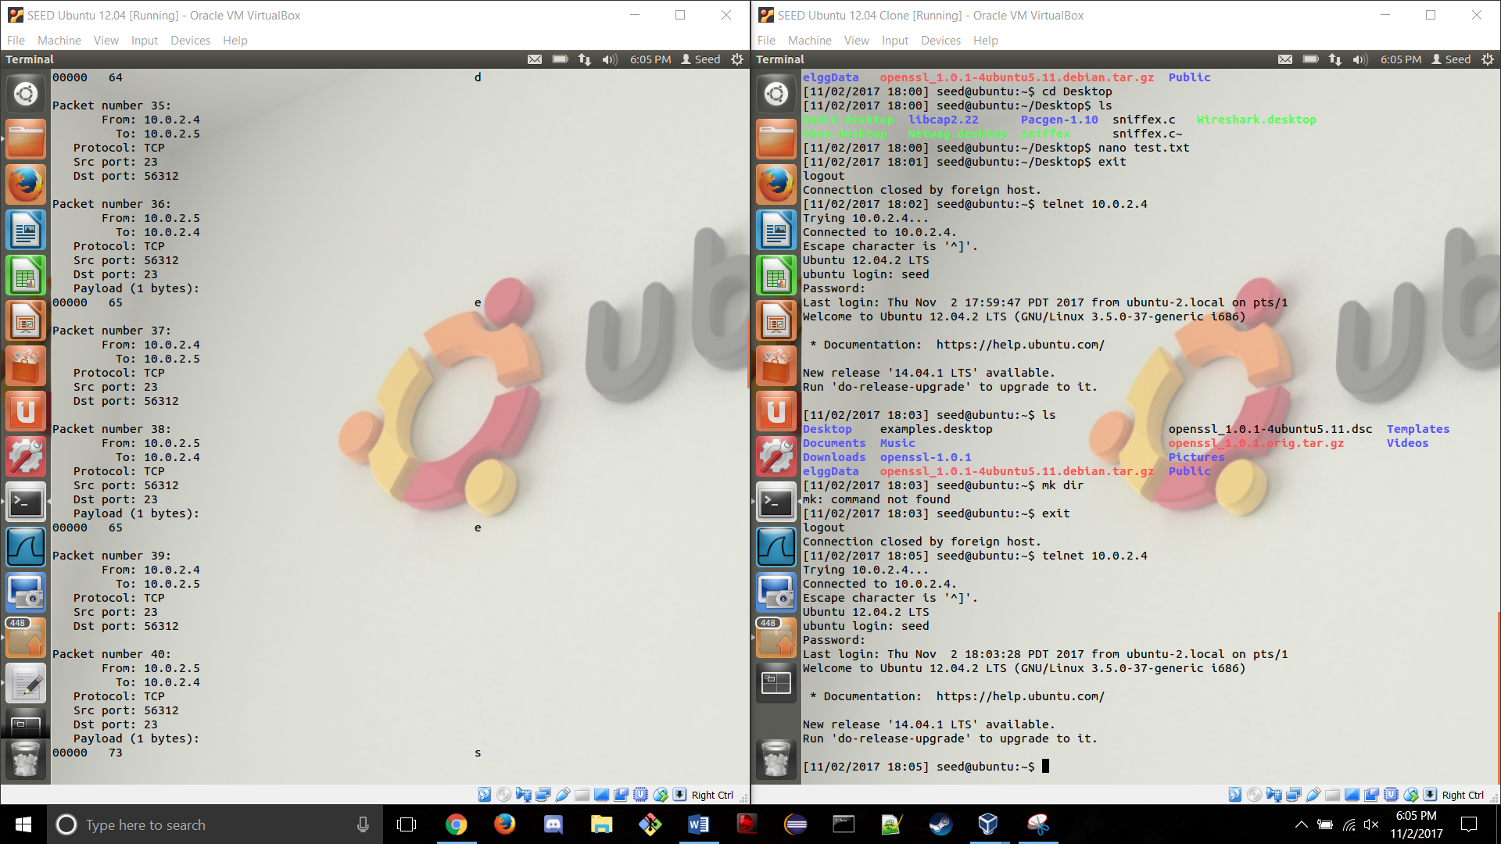

Using wireshark, it is still possible to find the users passwords at the bottom of the telenet packets. 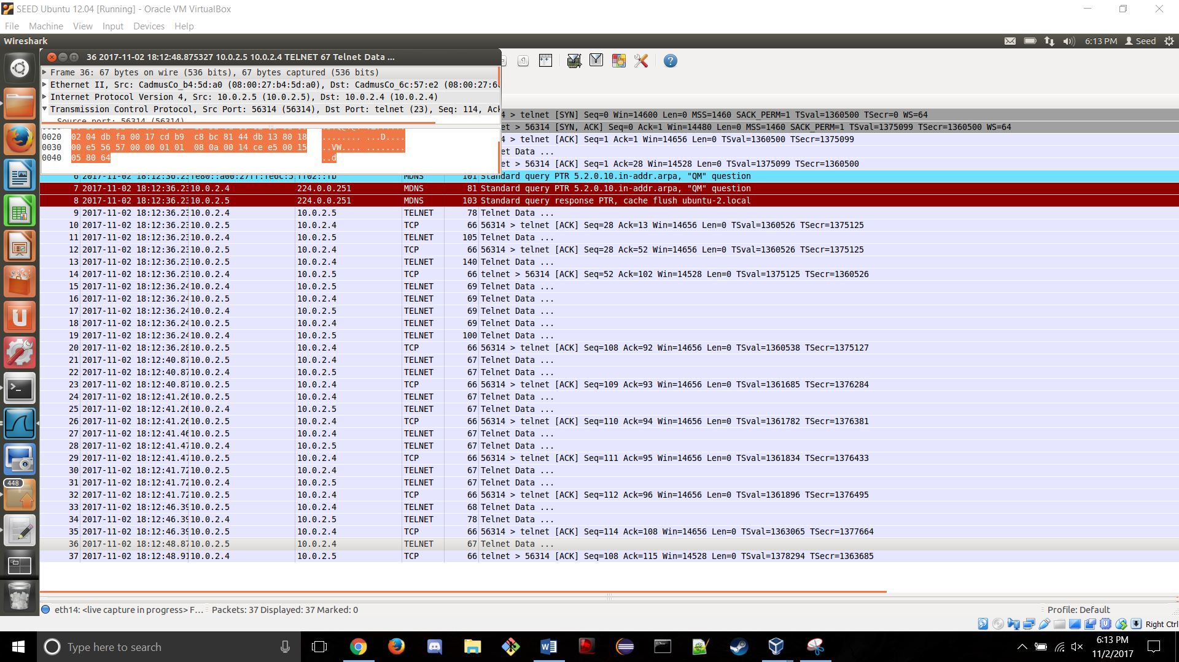

Telenet’s security is poor as anyone with enough knowledge and a sniffer can see the contents of the data.

3.4 Problem 4 SSH

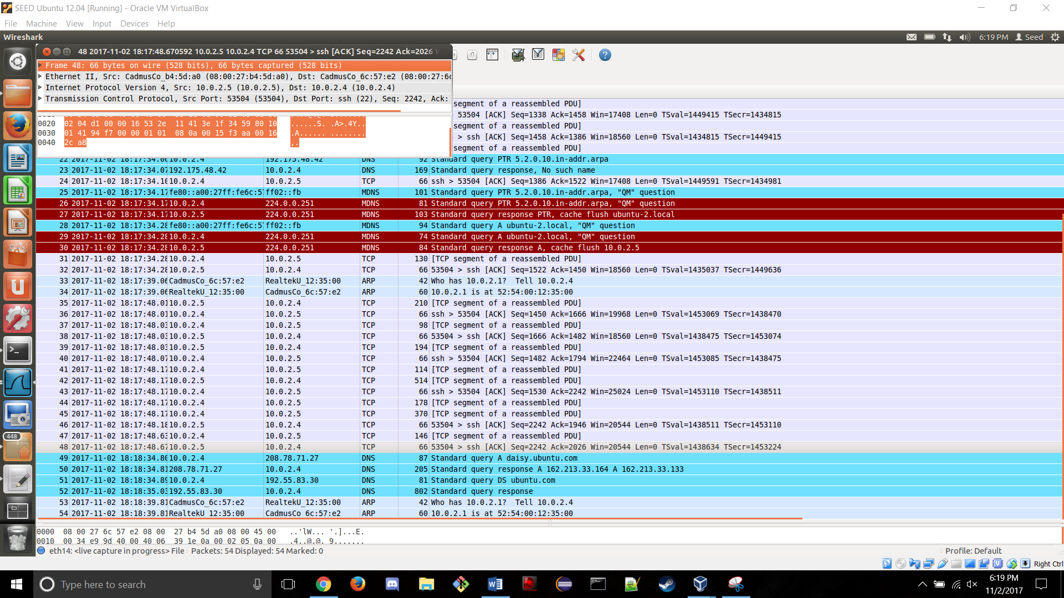

Even where the password characters should be it is encrypted so the actual password is not found.